HUSSEINI SULEIMAN
2025/FWSD/11478
fwsd2511478@students.icdfa.edu.ng
DATE: 28TH AUGUST, 2026
COURSE CODE: SBT-DF202 · Practical Laboratories

ASSIGNMENT: Lab 1 — Digital Forensics Case Handling, Autopsy and Sleuth Kit Analysis

our practical context
You are acting as a junior digital forensic analyst in the ICDFA laboratory. You have been provided with a forensic disk image named Ch01InChap01.dd. The requesting officer requires you to identify deleted files, recover relevant office documents, perform keyword searches, preserve your analysis steps, verify evidence integrity, and prepare a repeatable technical forensic report. The original evidence image must not be modified during the investigation.
Objectives

What you must demonstrate
By completing this lab, trainees will demonstrate their ability to apply the digital forensic investigation process in a controlled practical environment. Students will preserve and hash a forensic disk image, perform structured analysis using Autopsy, examine the image using The Sleuth Kit command-line tools, identify and recover deleted files, analyse file metadata and data units, perform keyword searches, verify recovered evidence using cryptographic hashes, and prepare a professional forensic report containing repeatable findings.
Students are expected to demonstrate practical competence with tools and commands including Autopsy, img_stat, mmls, fsstat, fls, istat, icat, blkcat, blkls, tsk_recover, md5sum and sha256sum.
Procedure

Laboratory instructions
Before beginning this lab, review the Module 1 and Module 2 lessons and study materials covering digital investigation procedures, evidence handling, chain of custody, forensic imaging, Autopsy and The Sleuth Kit.
Download the authorised training forensic image Ch01InChap01.dd and create a dedicated forensic working directory before beginning your analysis. If the direct download does not start automatically, use the browser download page instead. The source lab specifically provides this evidence image for the practical.
After downloading the evidence image, record the evidence source, file size, storage location, MD5 hash and SHA-256 hash before conducting any forensic analysis. Preserve the original image and perform recovery and examination activities in separate working folders.
ATTEMPT TO THE LABS
FILE INFORMATIONS:
File name: Ch01InChap01.dd
File size: 1440KB
Storage part: C:\INVESTIGATION FILE\ Ch01InChap01.dd ON WINDOWS
(kali㉿kali)-[~/husseinikalistudent/usb ON KALI
MD5HASH VALU: a117773bcf1fc88ec0ab8e0a349fbbcb Ch01InChap01.dd
Part A — Autopsy Analysis
Create a forensic case in Autopsy and add Ch01InChap01.dd as the evidence source. Identify deleted files, recover relevant files, perform keyword searches, tag relevant evidence and generate an Autopsy report. Record the case name, evidence source, deleted-file findings, recovered files, keyword-search results and reporting evidence.
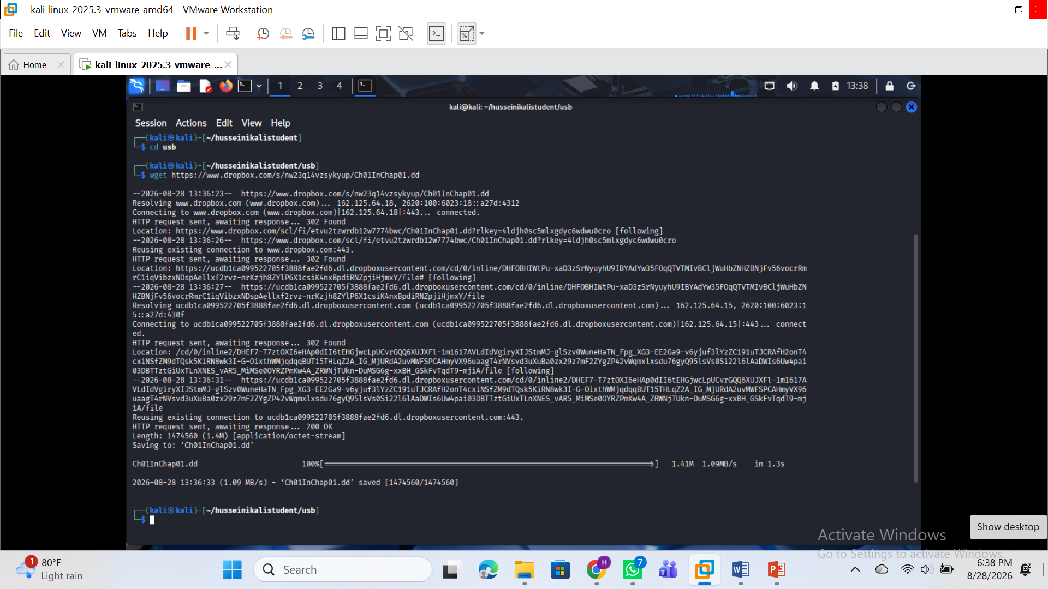

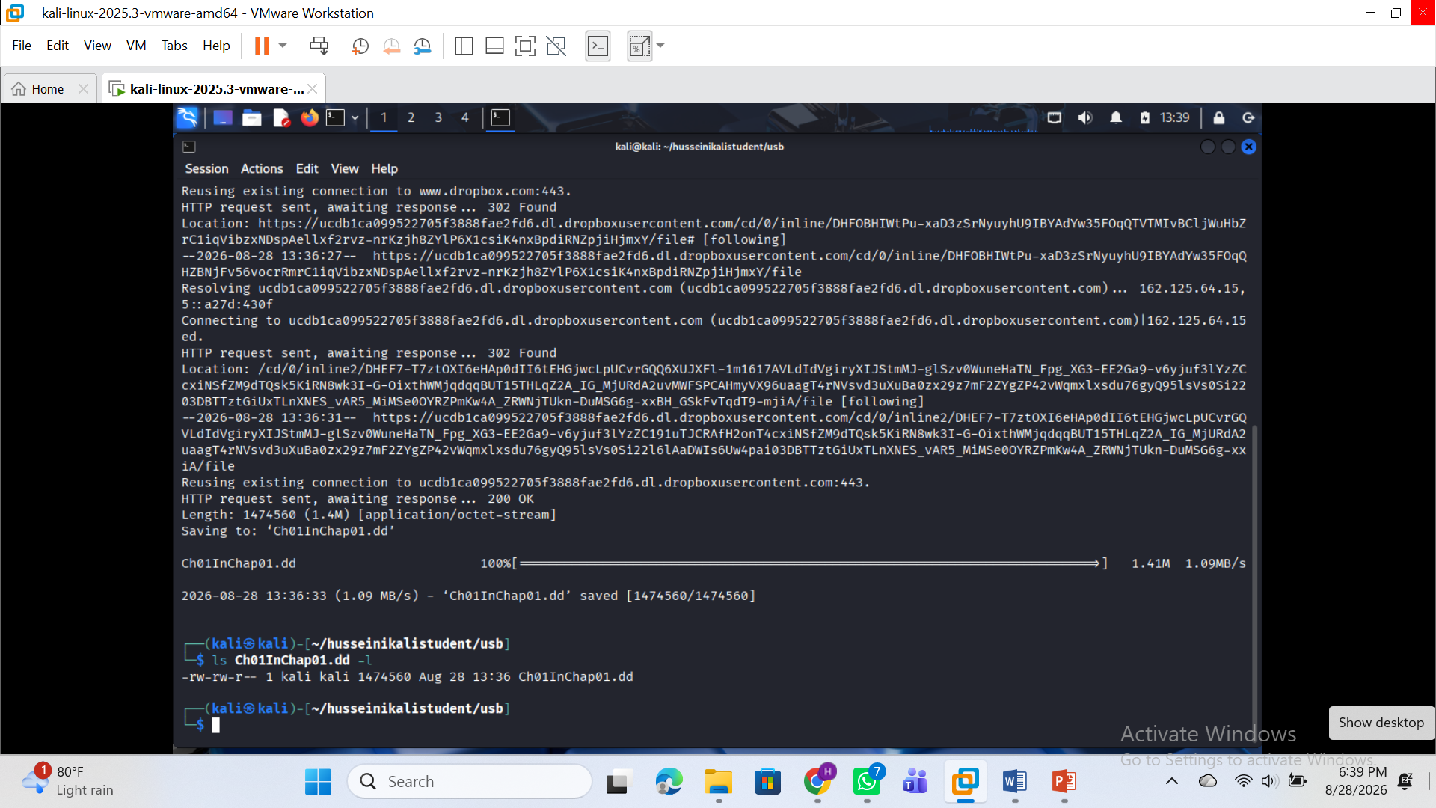
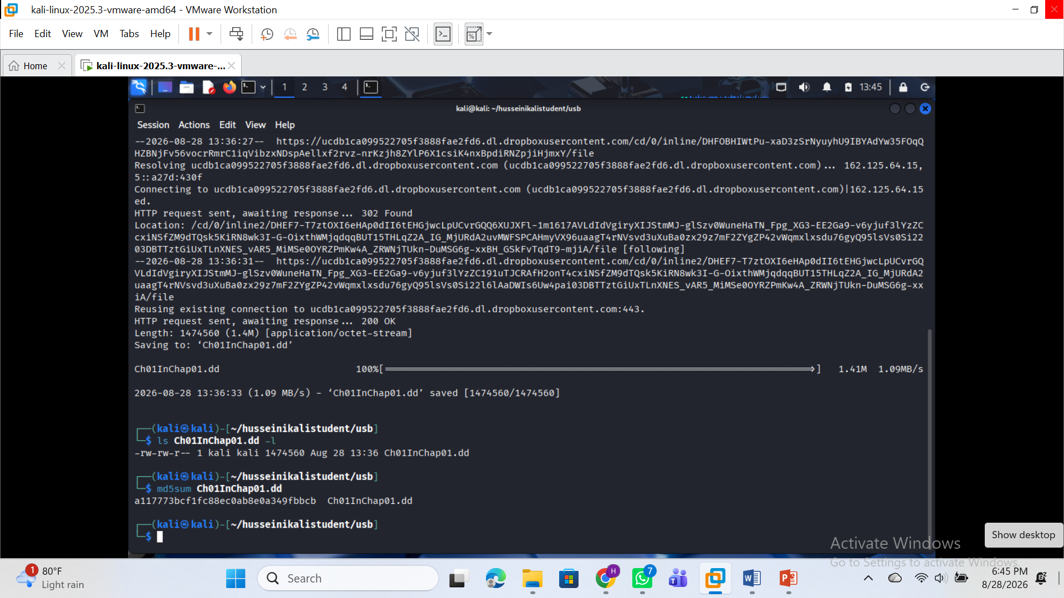
IMAGE TYPE AND SIZE: Image Type: raw
Size in bytes: 1474560
Sector size: 512

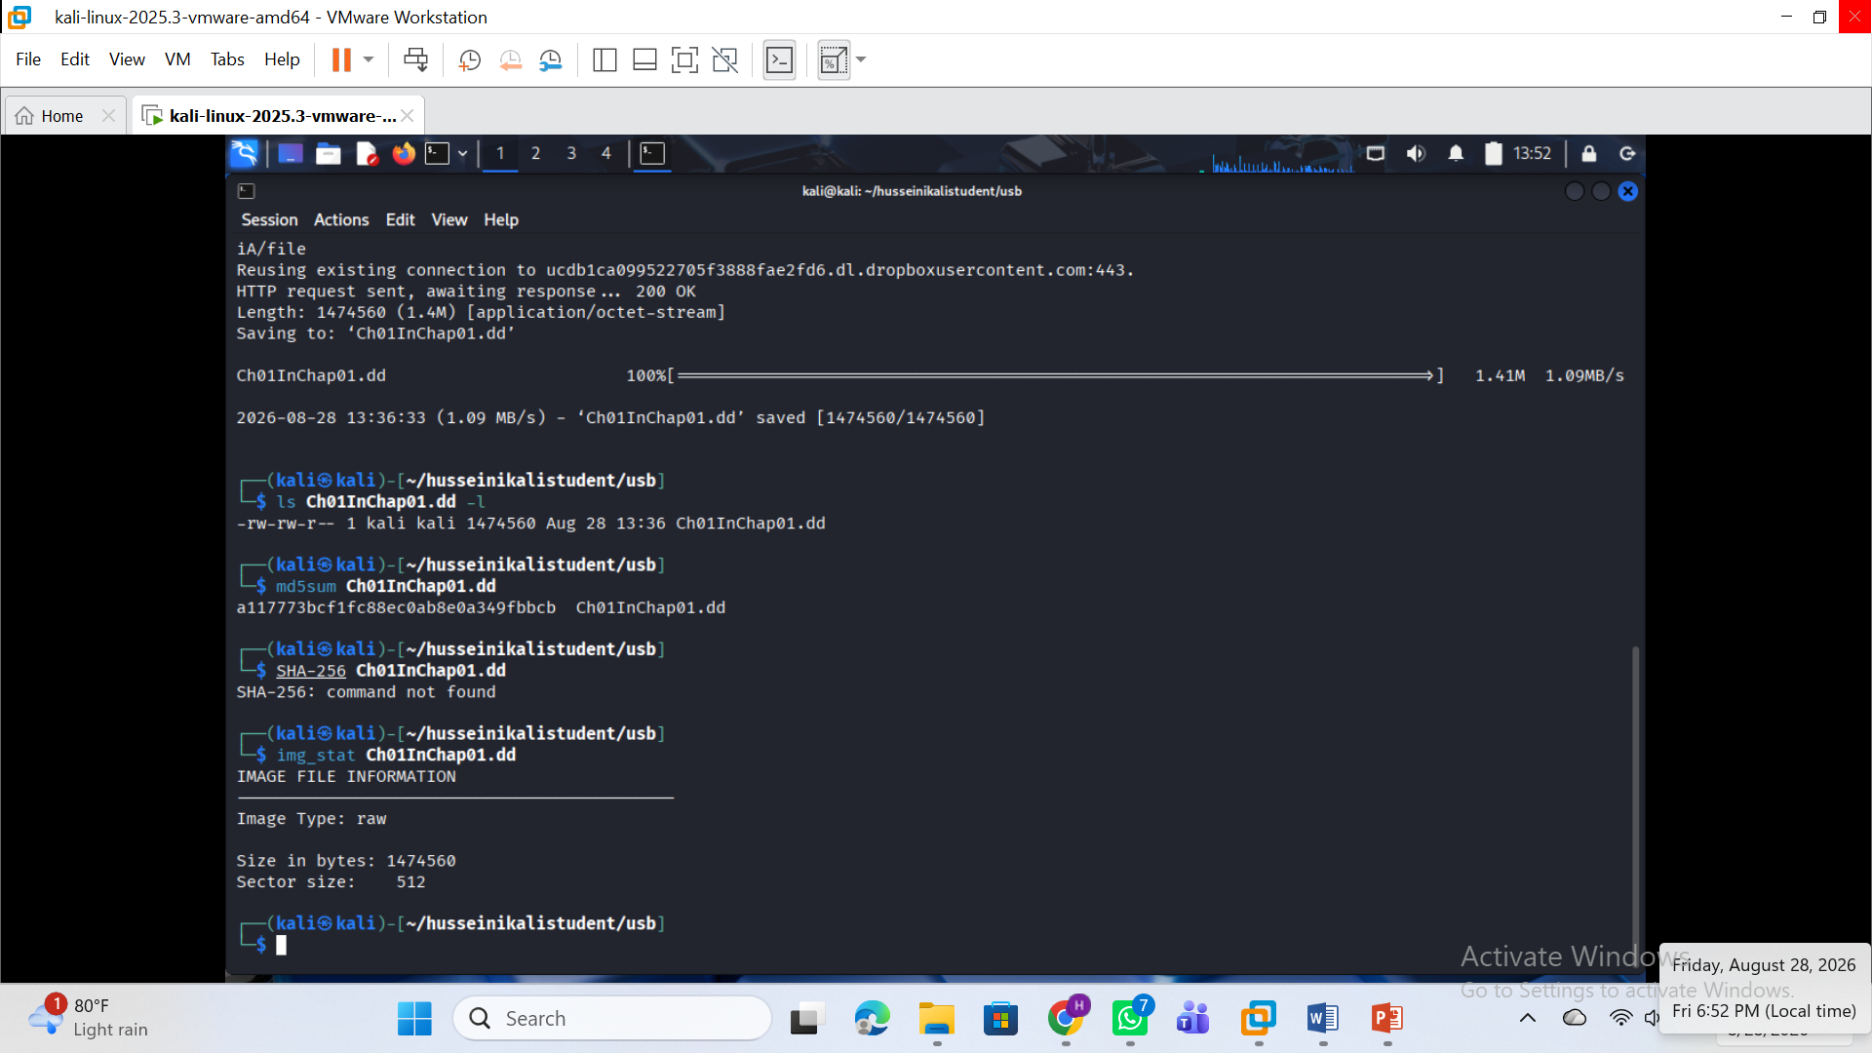
FILE DETAILS: SEE ATTACH using the command: fsstat Ch01InChap01.d
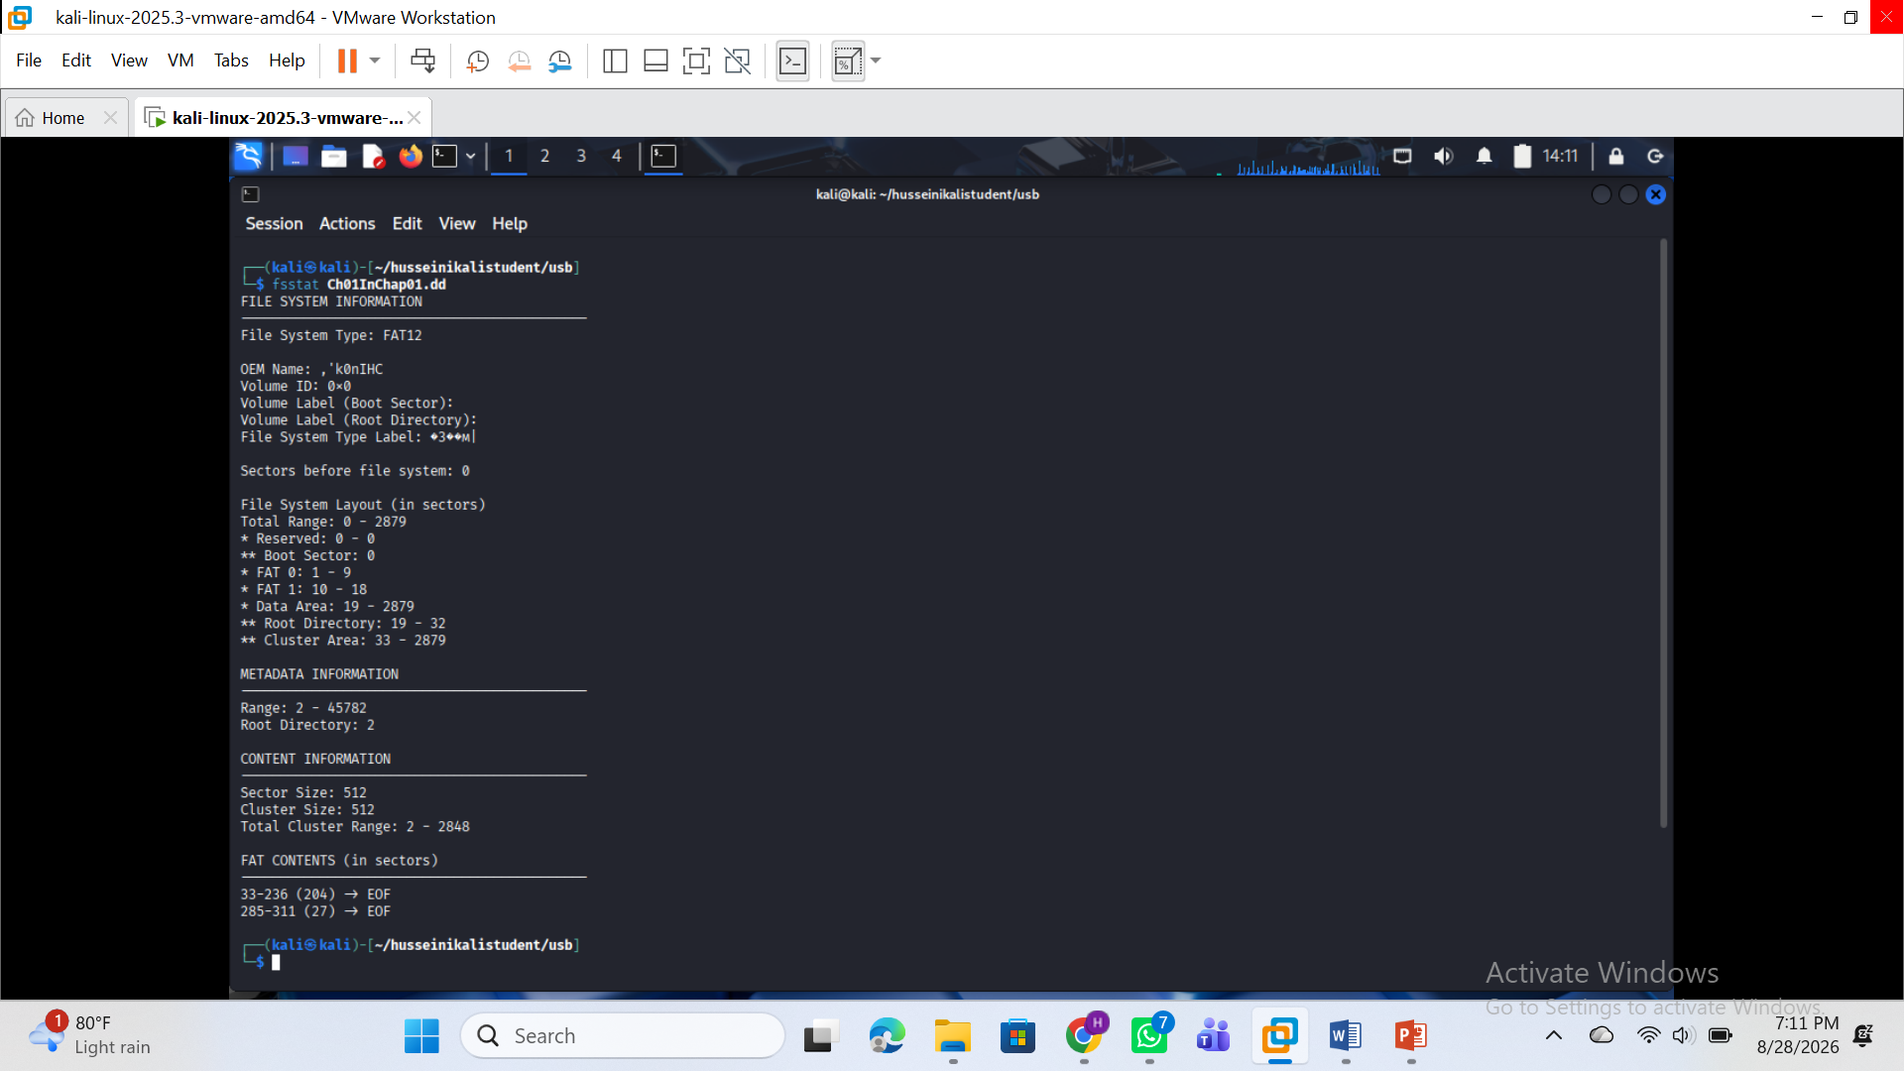

IDENTIFICATION OF DELETED FILES AND DIRECTORY AND ENTRIES
Command use to list List allocated and deleted file names in a directory: fls Ch01InChap01.dd 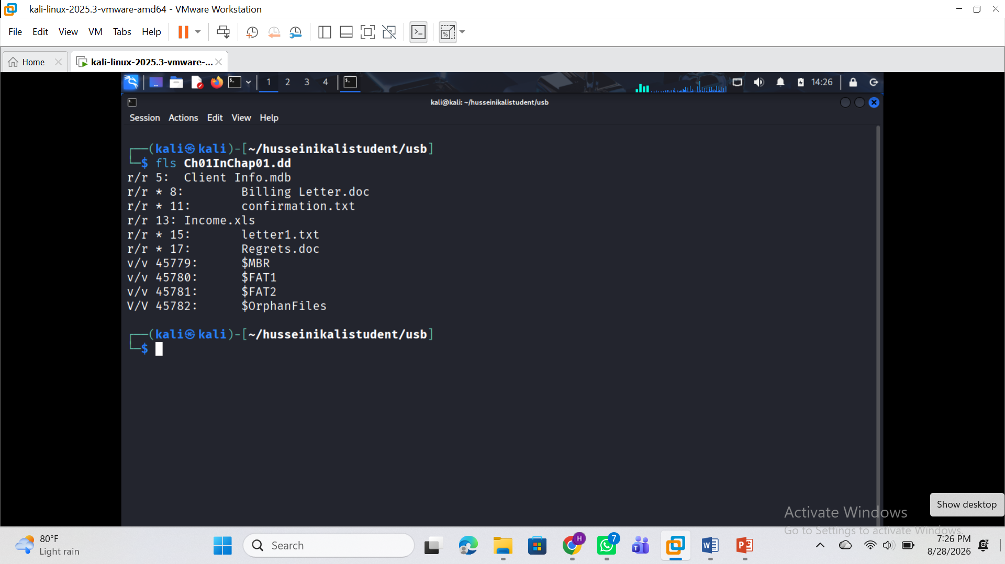
fls -d Ch01InChap01.dd : Is the Command used to Display deleted entries only
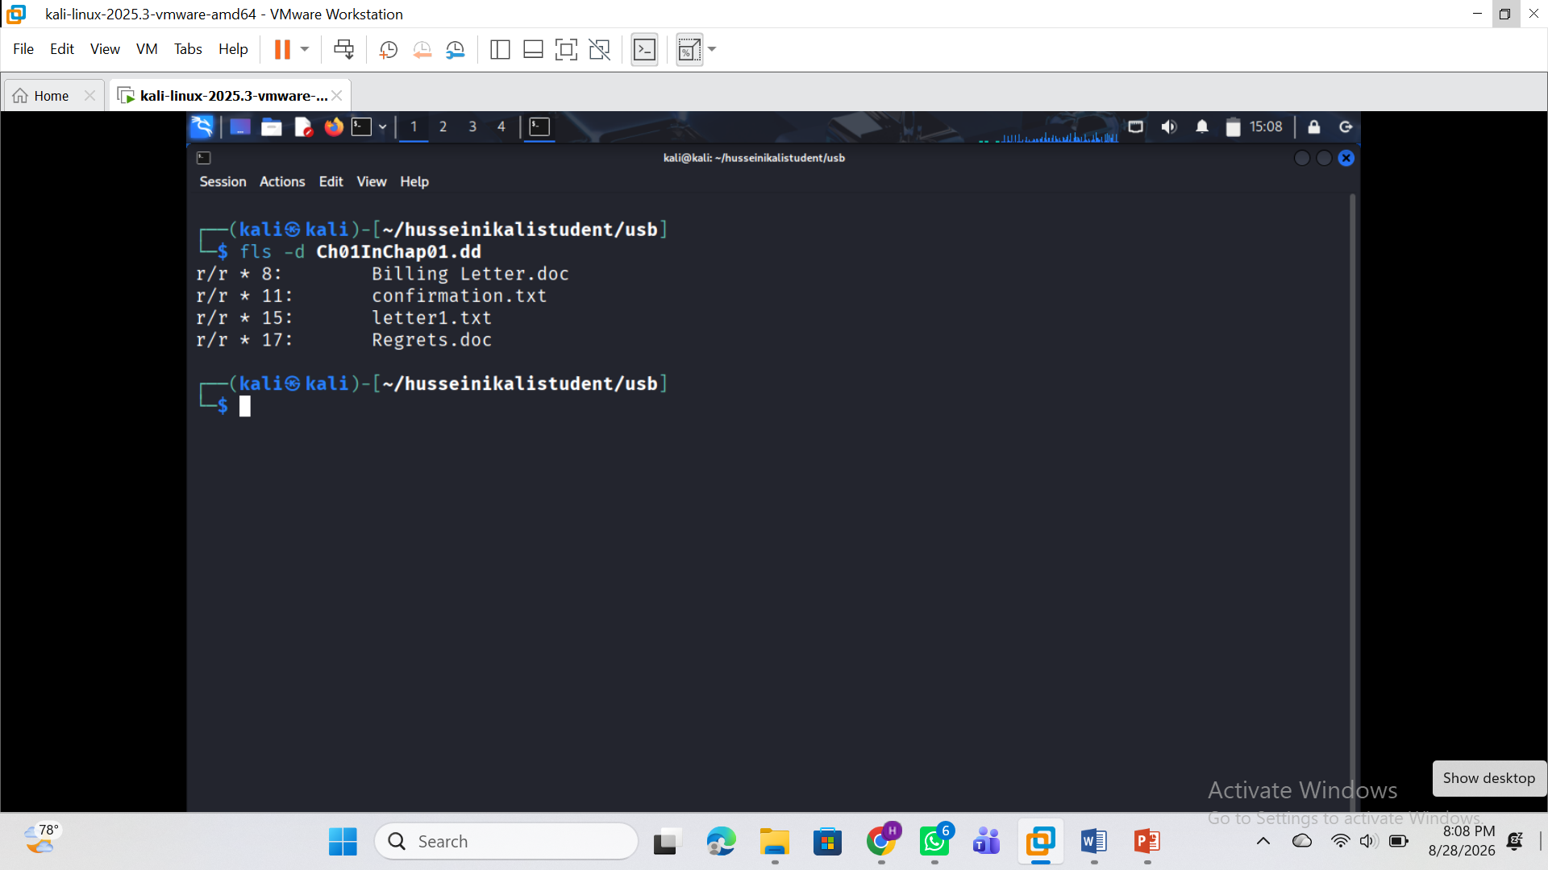

Recover deleted files using inode without specifying a file name
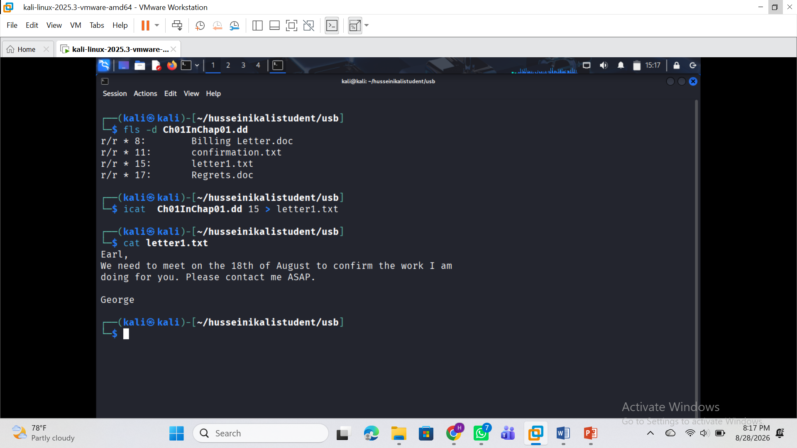
Comand used:
icat Ch01InChap01.dd 15 > letter1.txt
cat letter1.txt

Extract the data units of letter1.txt (inode15)

See attach
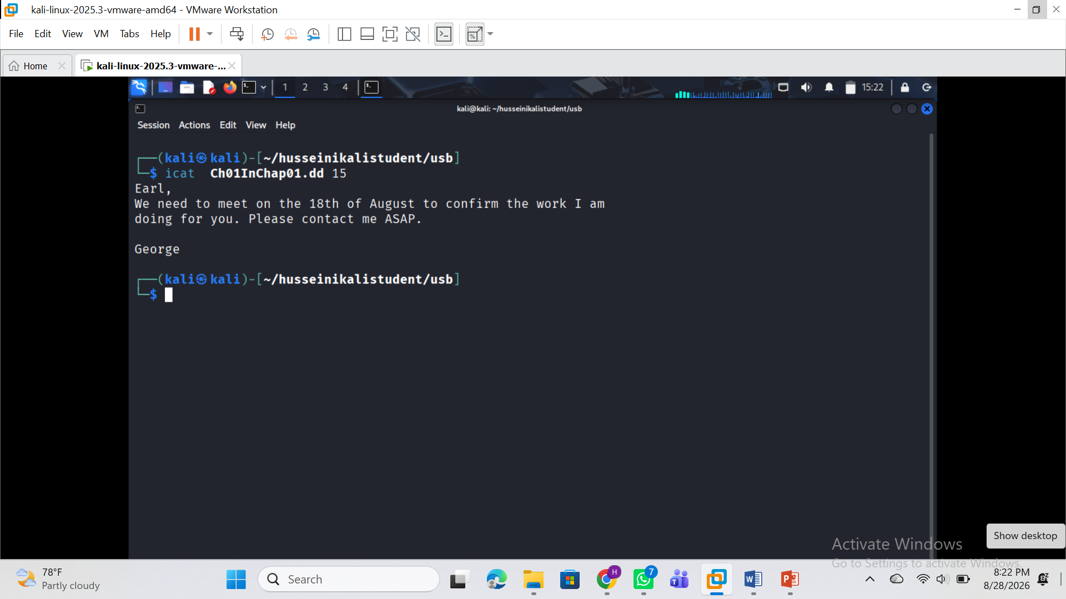

Display the statistics and details about a given meta data structure
Command used: istat Ch01InChap01.dd 15
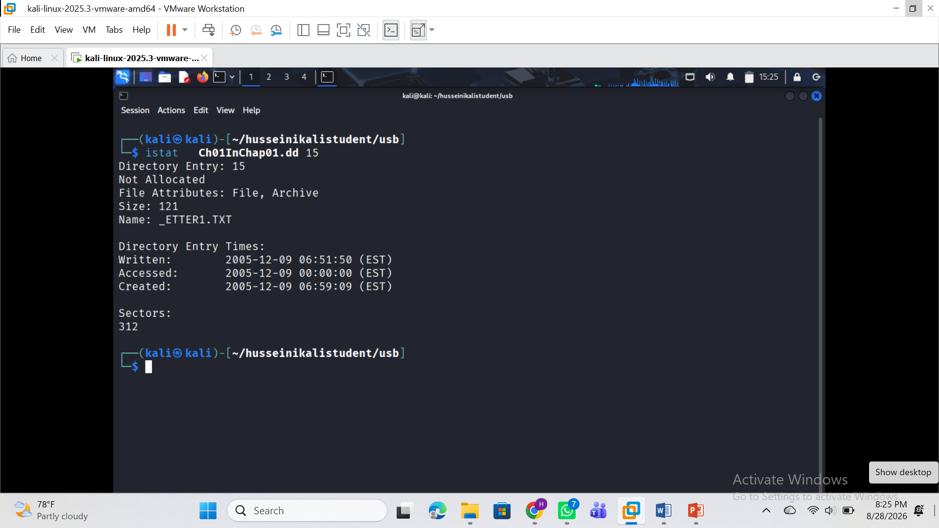

Part B — Sleuth Kit Analysis
Examine the forensic image using img_stat, mmls, fsstat and fls. Identify deleted files and locate INCOME.XLS. Determine its metadata address, examine its metadata and data units using istat, recover it using icat and blkcat where applicable, perform additional recovery using tsk_recover, and compare the hashes of the recovered copies.
Document every significant command, output, observation, error and corrective action. Screenshots must clearly support the work claimed in your report.
Attempt:
Extract the contents of a given data unnits
Command used: blkcat Ch01InChap01.dd 312
See attach: 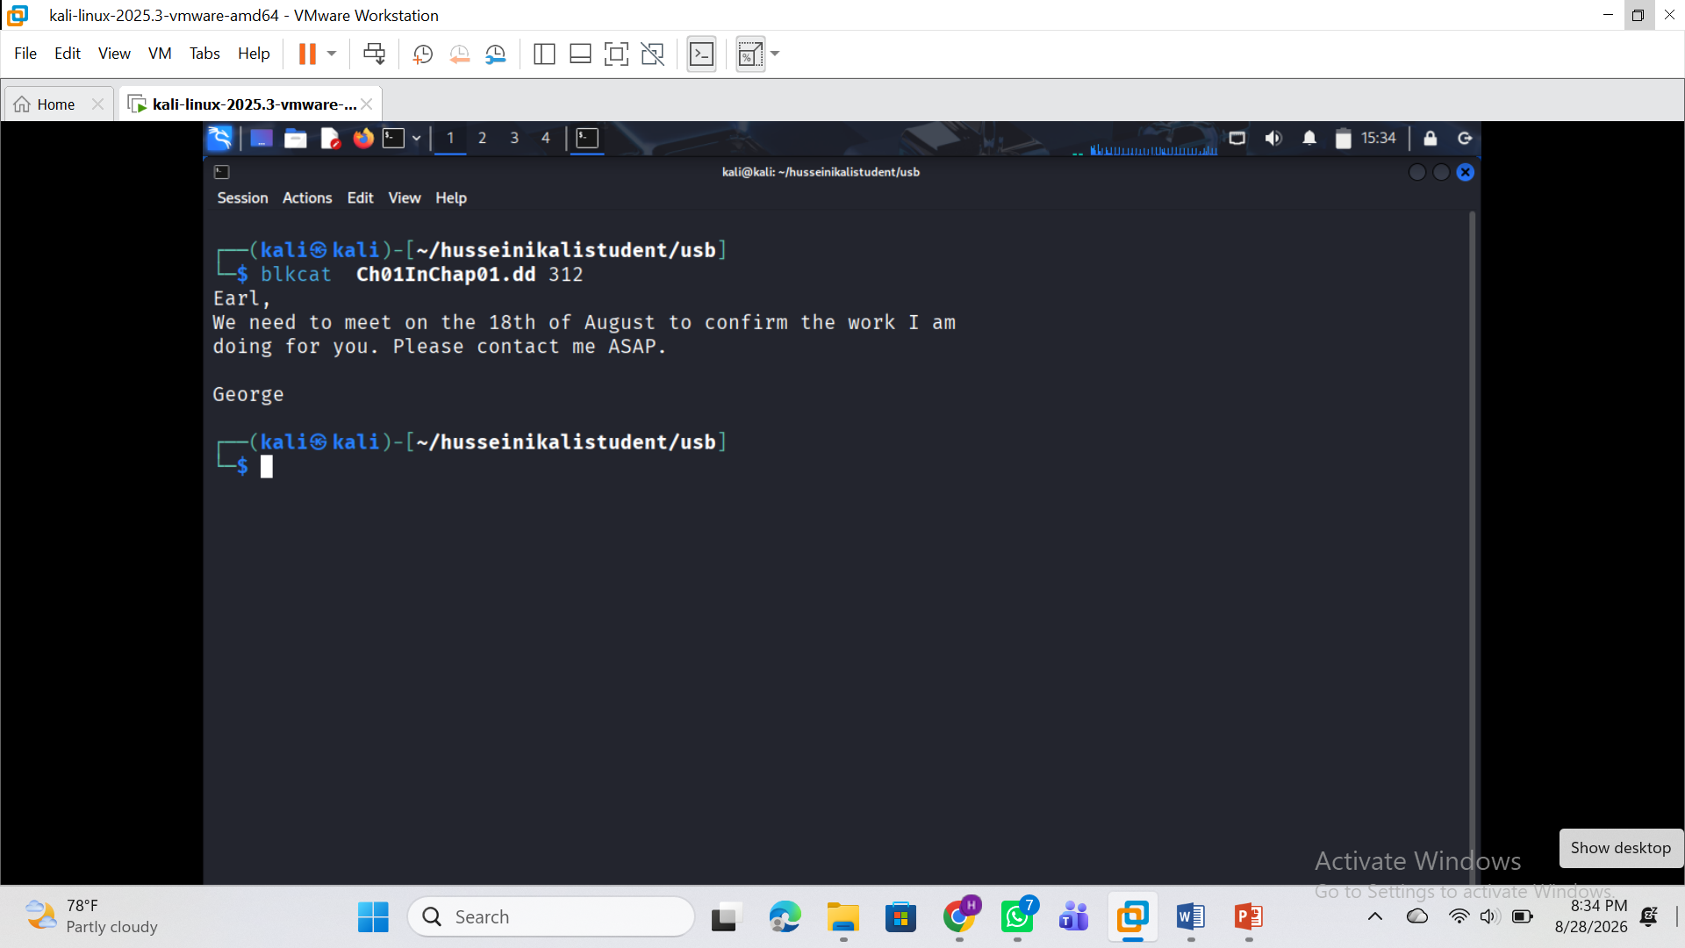
Command used: blkls Ch01InChap01.dd 312-312:
For: List the details about data units and can extract the unallocated space of the file system

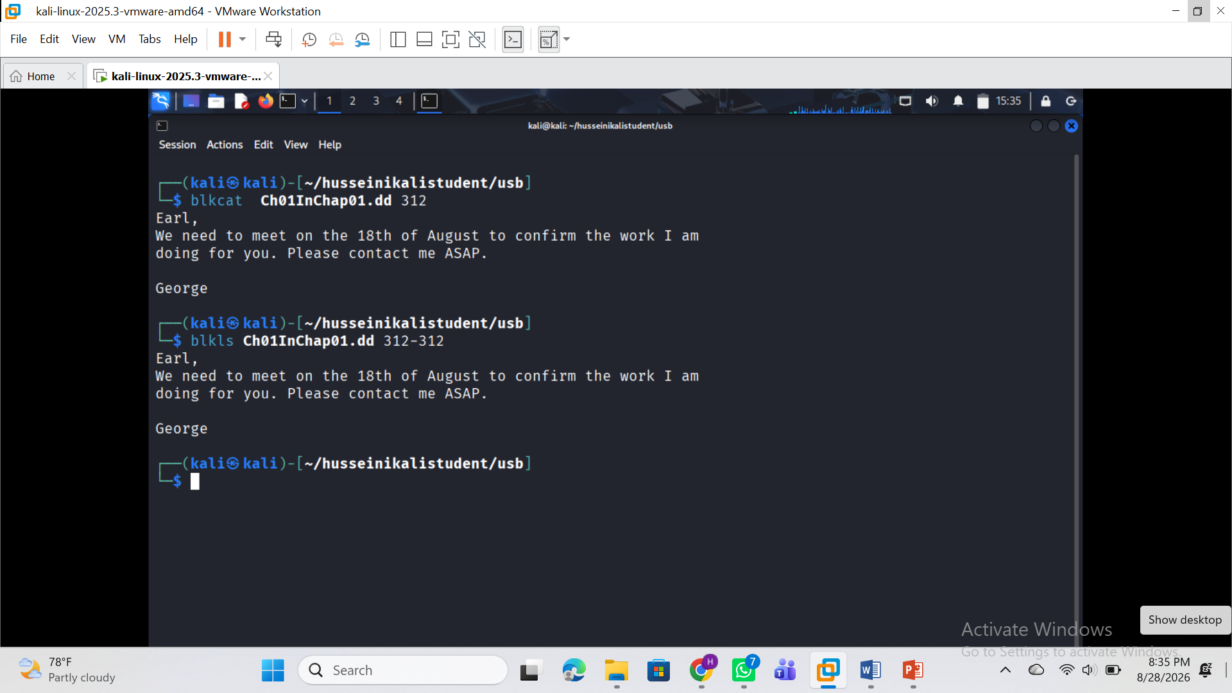
Extracting the contents of a given data unit in Hex
Command used: blkcat Ch01InChap01.dd 312|xxd
See attach: 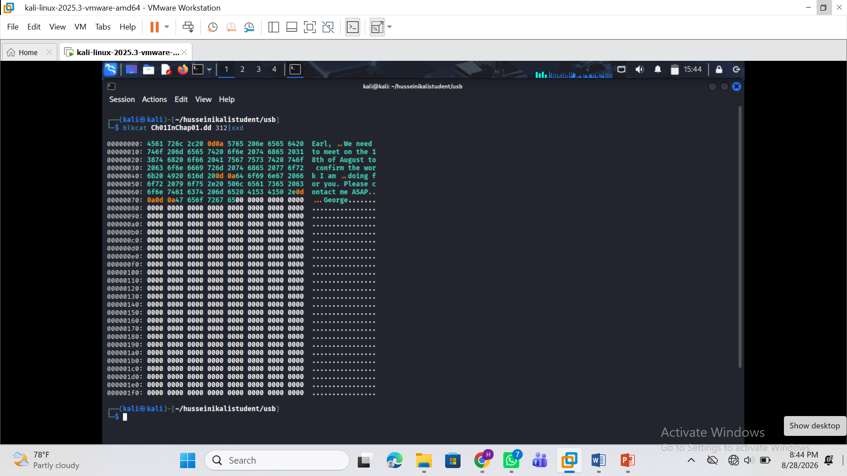
Show A file with multiple sectors
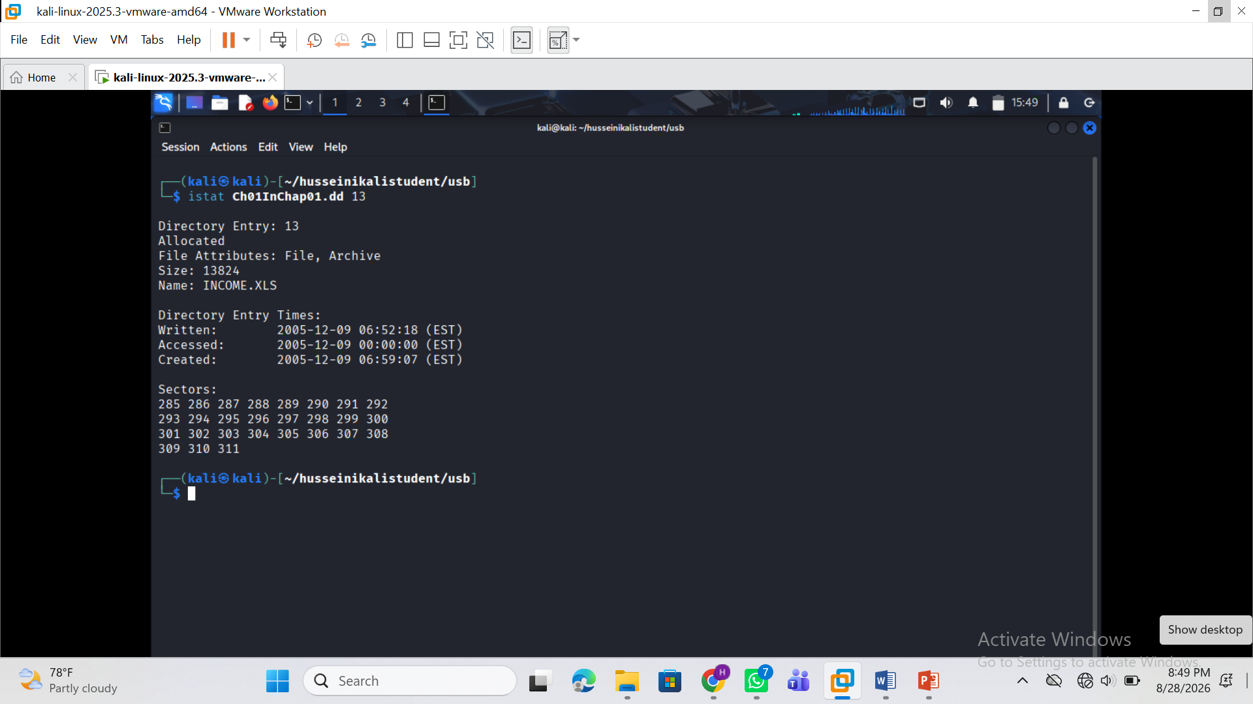

Mounting a USB image
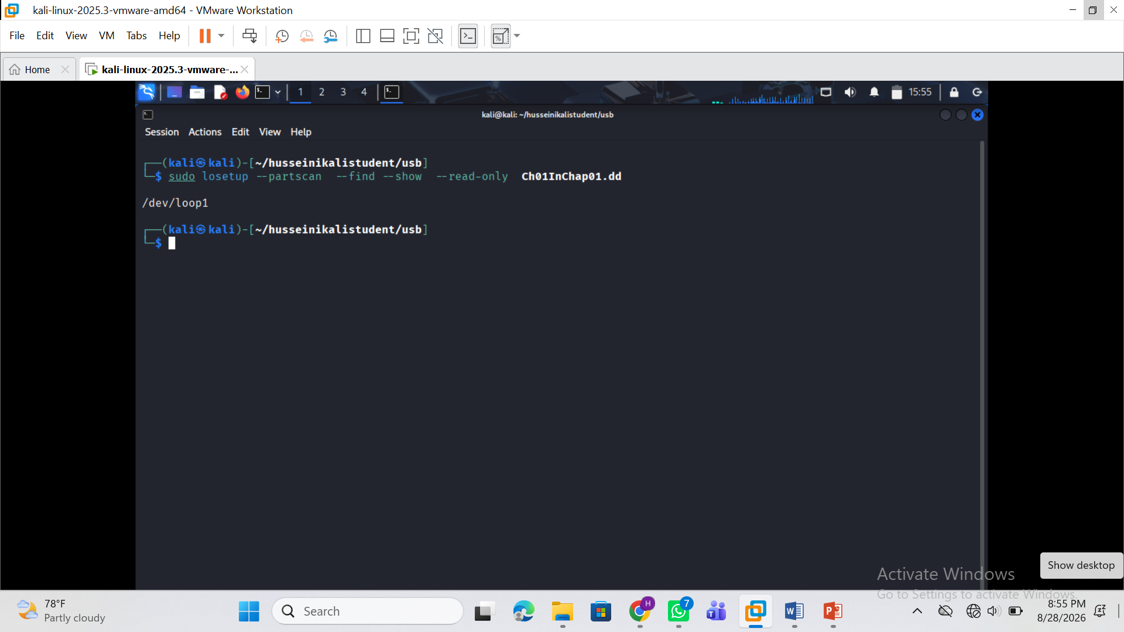

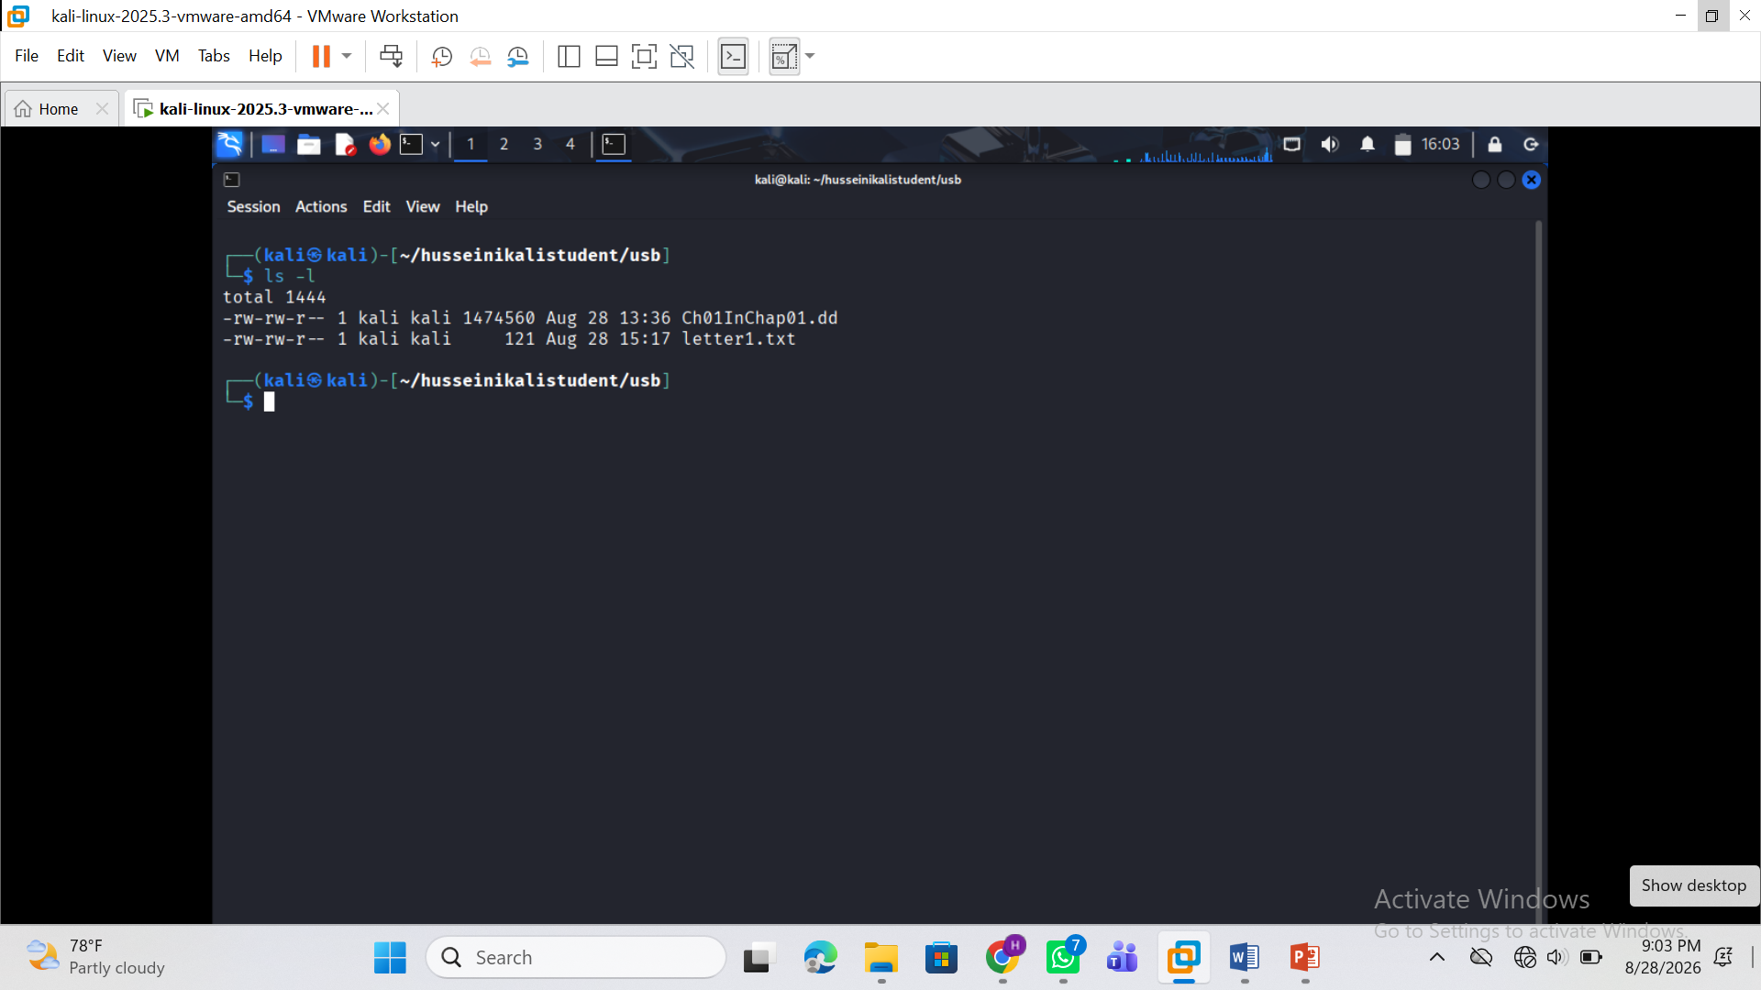

Do not modify the original forensic image. All recovered evidence, screenshots, command outputs and reports must be stored separately from the source image.
Required evidence
Students must submit evidence demonstrating completion of the practical, including:
1. Dedicated lab folder structure.
2. Evidence image filename, size and storage location.
3. MD5 and SHA-256 hashes of Ch01InChap01.dd.
4. Completed mini chain-of-custody/evidence worksheet.
5. Autopsy case creation and evidence source configuration.
6. Autopsy deleted-file listing.
7. Autopsy keyword-search results.
8. Tagged/recovered Autopsy evidence and generated report.
9. img_stat, mmls/fsstat and fls outputs.
10. Recursive deleted-file listing using fls.
11. Identification of the metadata address for INCOME.XLS.
12. INCOME.XLS recovery using icat.
13. istat output showing file size and relevant data units.
14. blkcat recovery attempt and resulting evidence.
15. Hash comparison of recovered INCOME.XLS copies, including tsk_recover where applicable.
16. Evidence that the recovered spreadsheet was successfully examined or converted locally.
The final submission must include one professional PDF forensic report containing explanations and screenshots, together with the required ZIP archive containing recovered files, reports and screenshot evidence. The original DD image must not be submitted unless specifically requested by the instructor.
Lab access notesThis practical forms part of the first laboratory assessment window. Students must review the relevant Module 1 and Module 2 lessons and study materials before beginning. Use only the authorised training evidence supplied for this lab. Maintain evidence integrity throughout the exercise and do not modify the original DD image. Submission must include the required PDF forensic report and supporting evidence files.

